Falkland Islands Statute Law Database Web User Guide

Statute Law Database Web User Guide

Version 1.0.0 (dated 29 July 2017)
Prepared by:
Jonathan Doguet

 | 

Table of Contents
1. Introduction 1
1.1 Purpose 1
2. Home Page 2
2.1 Page Banner 2
2.2 Main Display Area 3
2.2.1 Information Area 3
2.2.2 New In Force Legislation Pane 4
2.2.3 New Legislation As Made Pane 4
2.3 Page Footer 4
3. Searching 6
3.1 Basic 6
3.2 Advanced 9
3.3 Saved 10
3.4 Search Results 11
4. Browsing 16
4.1 By Title 16
4.2 Browse Results 17
5. Document View 19
5.1 Contents Pane 19
5.2 Content Viewing Area 20
5.2.1 Document Toolbar 21
5.2.2 Hit Highlighting 22
6. Legislative History 24
7. Profile 25
7.1 Change password 25
7.2 Subscriptions 27
Table of Figures
Figure 1 – Falkland Islands statute law database Website Home Page 2
Figure 2 – Basic search form and its default settings 7
Figure 3 – Advanced search form and its default settings 9
Figure 4 –Results section with search results below the Search form 11
Figure 5 – Browse page with Results section below the browse tools section 17
Figure 6 – Document View for an instrument 19
Figure 7 – Content viewing area with hit highlighting (from a search result) 20
Figure 8 – Legislative History page 24
Figure 9 – Profile page 25

Introduction

Purpose
The purpose of this document is to provide guidance to users of the Falkland Islands Statute Law Database Website in how to use the system functions. Users will be any person wishing to access the legislation of the Falkland Islands.

Home Page
The Falkland Islands Statute Law Database Website Home Page, as shown in Figure 1, provides public and government users with access to the Falkland Islands Government’s legislative instruments and associated documents. The Home Page is organised into the following functional areas:
- a page banner that is present on all pages in the system,
- the main display area, or large display area, with:
  - an information area,
  - a New in force and New legislation as made pane,
- a page footer that is present on all pages in the system.
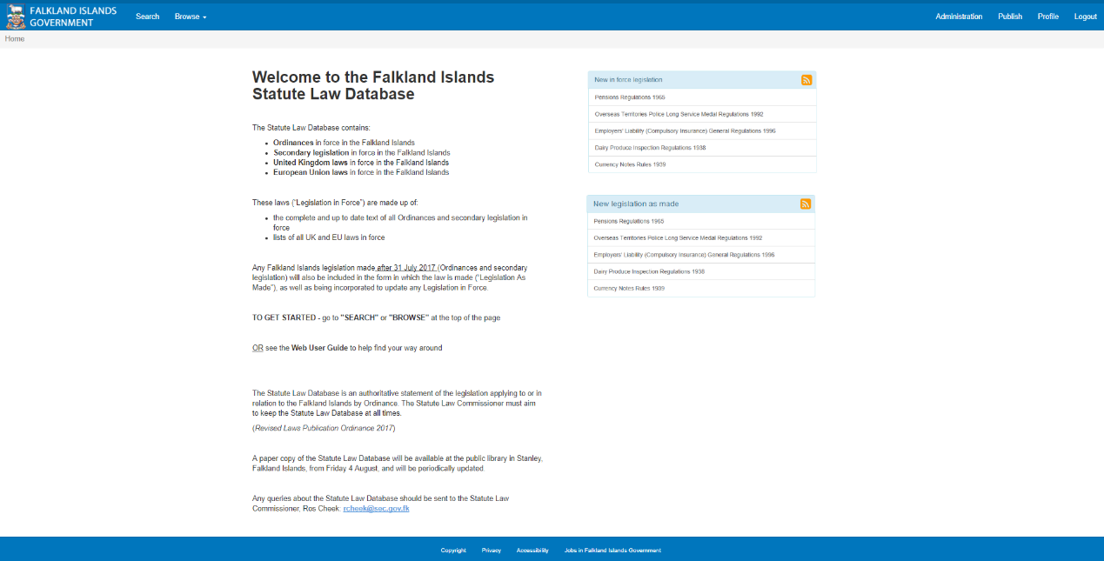
Figure 1 – Falkland Islands Statute Law Database Public Website Home Page

Page Banner
The Page Banner located at the very top of the Home page—as well as all other pages—identifies the system. It also provides navigation throughout the system as follows:
- Falkland Islands Government Coat of Arms that is clickable for quick access to the Home Page of the website
- Search – a simple facility for performing quick searches
- A dropdown Browse menu with clickable menu items for accessing the various browse aspects of the system as follows:
  - Legislation As Made
  - Legislation In Force
  - UK Legislation
  - EU Laws

Main Display Area

Information Area
The Information Area simply contains some general information about the system as follows:
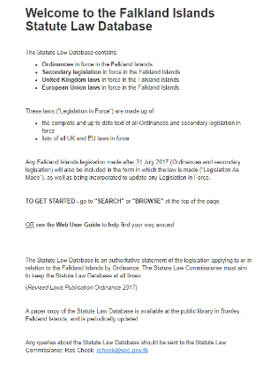

New In Force Legislation Pane
The In Force pane displays the document titles and their categories for recent editions of legislation with a clickable button allowing the user to subscribe to information about new in force legislation, as follows:
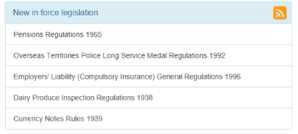

New Legislation as made Pane
The New Legislation as made pane displays the document titles and their categories for new legislation with a clickable button allowing the user to subscribe to information about new legislation as made, as follows:
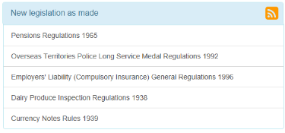

Page Footer
The Footer is located at the very bottom of the Home page—as well as all other pages—contains some general links regarding the website as follows:
- Links to Falkland Islands Government maintained general pages regarding the site as follows:
Copyright | – a page containing copyright information for material on the website
Privacy | – a page containing a privacy statement about the collection and use of personal information
Accessibility | – a page with a statement relating to the accessibility of content on the website
Jobs in Falkland Islands Government | – link to the Falkland Islands Government Jobs website page

Searching
Powerful searching can be performed on the Search page that is accessed via the Search menu item.
Three tabs on the Search page provide access to forms for the following search options: Basic (the default), Advanced, Menu assisted and Saved.
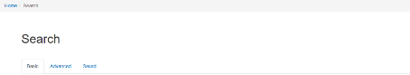
The simplest search is to enter one or more search terms (the search query) into the Search for field of the form, e.g. “tax rates”. Terms entered into the Search for field are text searches, that is, they search both descriptive information and the content of legislation records. Search terms are not case sensitive, therefore you may enter UPPER or lower case characters without affecting the result, e.g. “Tax rates” will have the same result as “tax rates”.
If a user’s search yields no results, and their search contains common words, then the system will alert the user that their search term or terms can be changed to a ‘recommended’ term in order to produce results or even just correct misspellings in the query!
All of the Search forms are organised with an upper Search section where search parameters are entered and a lower Results section that displays the search results.

Basic
The Basic search tab displays a form with limited search options for performing simple searches. The search options available on this page allow a user to search only selected fields, or the entire content, of different types of legislation and if required, constrain the search to a specific year and/or number as well as allowing for point in time searches. An example of the Basic search form including its default settings is shown in Figure 2.
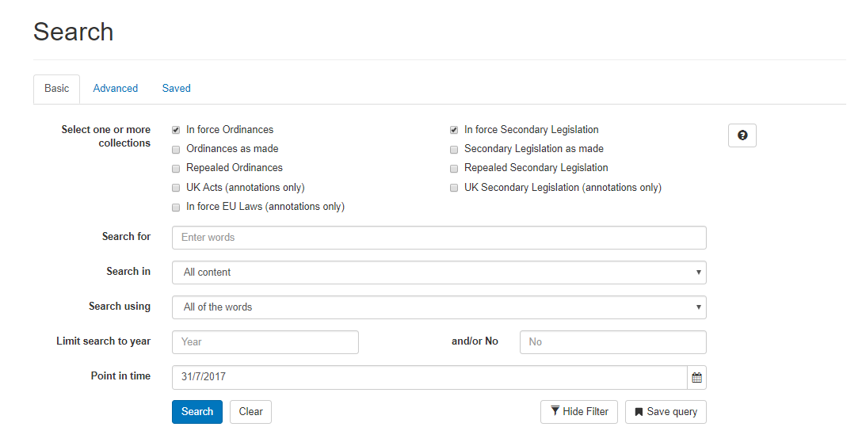
Figure 2 – Basic search form and its default settings
The Basic search form allows the specification of the following parameters when building a search query:
- Collection:
A search may be constrained to a particular collection, or set of collections, by checking the checkbox(es) for the collection(s) as required
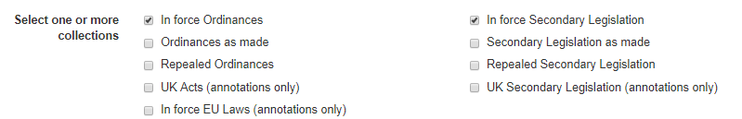
- Search for:
The search term(s) are entered into this field
- Search in:
A drop down list of available fields allows the search to be constrained as follows:
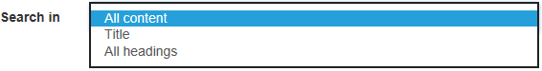
- Search using:
A drop down list of search term combinations that relate to the search term as follows:
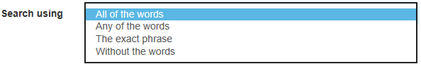
- Search limit(s):
The search may be constrained to a year and/or a number through the use of the following fields:
- Point in time search:
The search may also be restricted to a particular point in time using the following field:
The Clear button at the bottom of the form clears the search terms and resets all of the form fields back to their default settings and the Search button executes the search using the parameters specified on the form.

Advanced
The form for the Advanced search tab is basically the same as that for the Basic search tab but with provision for combining multiple search conditions to build more complex queries. An example of the Advanced search form including its default settings is shown in Figure 3.
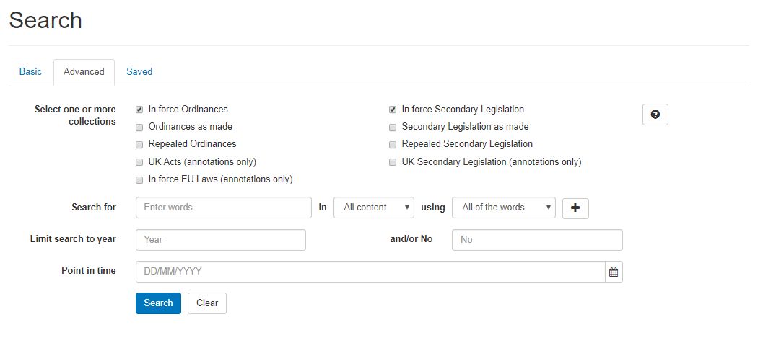
Figure 3 – Advanced search form and its default settings
The Advanced form contains all of the fields found on the Basic search form with the same layout except for the conditions fields: Search for, Search in and Search. These fields are now arranged horizontally in a row across the form to accommodate the inclusion of additional search conditions in rows thereunder as follows:
The search condition rows include the ability to add additional conditions by pushing the plus button:
The additional search condition rows include an extra drop down list selector with the last condition row also including an extra button as follows:
- a drop down list of operators allows the user to specify how the additional condition is to be combined with the other condition(s):
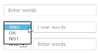
- a minus button for removing additional conditions:

Saved
The Saved search tab displays a list of previous searches that have been saved by the user for quick access.
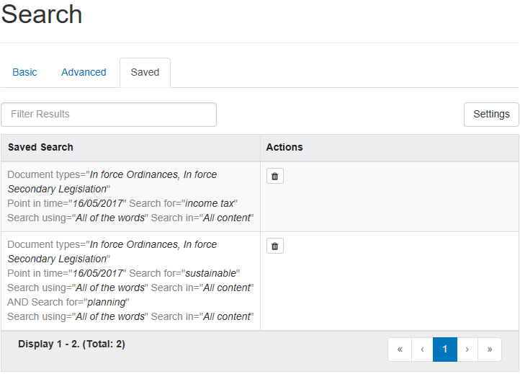
The saved searches are displayed in a table offering the following functionality:
- Selected metadata for each item is displayed in columns as follows:
  - Saved search – Displays the details of the saved search (this is a clickable link that will load the selected search)
  - Actions – Displays a button to remove the saved search

Search Results
Search results are displayed in a Results section positioned below the Search form, as shown in Figure 5. The section is comprised of a results table that occupies most of the section and is accompanied with two rows above and a row below the table to accommodate information and tools for use with the table.
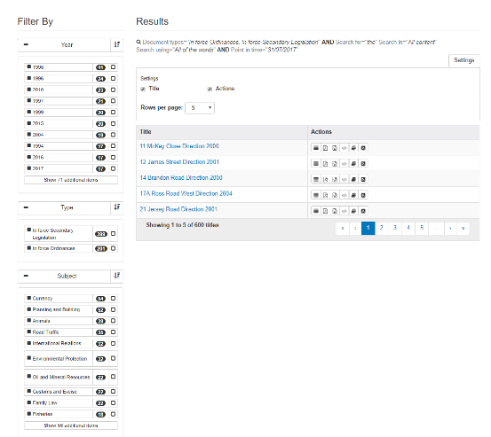
Figure 4 –Results section with search results
below the Search form
The first row of the Results section displays the query that was applied with the user specified parameters shown in black.
The search page now has the following tools available:
- Save Query – Saves the currently displayed search and goes to the ‘Saved’ tab
- Clear – Closes the faceted search functionality and removes any filters that may have been in place
The bottom row of the Results section provides functionality as follows:
- A summary of how many search results are displayed of the total results returned.
- A navigation tool bar with buttons for navigating around the various pages of items in the Results list with the following functionality:
  - << – when enabled, displays the first page of items
  - < – when enabled, displays the previous page of items
  - Up to five numbered buttons enabled, for non-empty lists,
  - > – when enabled, displays the next list of items
  - >> – when enabled, displays the last page of items
The list of legislation that meets the search criteria is displayed in a table offering the following functionality:
- Selected metadata for each item is displayed in columns as follows:
  - Title (that is a clickable link that loads the instrument)
- An additional Actions column provides seven tools for use with each item in the list:
  - Show/Hide hits () button – shows/hides snippets, from each of the instrument fragments containing matches, that contain:
    - the fragment title that is clickable to load the instrument fragment
    - a line containing the highlighted match(es) from the fragment
    - the count of matches in the fragment displayed on the far right side of the snippet
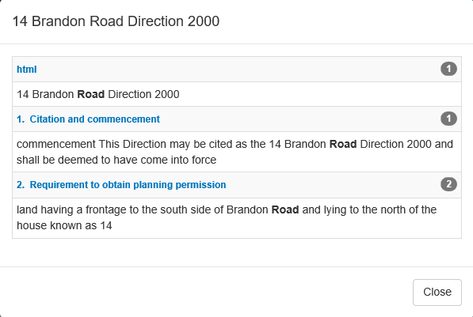
  - Download PDF () button – downloads the PDF document for the selected title
  - Download Word ()button – downloads the Word document for the selected title
  - Download Legislative History ()button – downloads the XML document for the selected title
  - View Whole Document ()button – that displays a Document View of the entire instrument with hit highlighting
  - New or updated Versions Feed () button – Downloads (or subscribes to depending on your browser settings) the new or updated versions feed for the selected title
The last row of the Results section provides functionality as follows:
- The range of items displayed out of the total number of items in the results list
- A navigation tool bar with buttons for navigating around the various pages of items in the browse Results list with functionality as follows:
  - << – when enabled, displays the first page of items
  - < – when enabled, displays the previous page of items
  - Up to five numbered buttons enabled, for non-empty lists,
  - > – when enabled, displays the next list of items
  - >> – when enabled, displays the last page of items
There also exists a Filter By section on the left side of the Results screen, which allows users to filter their results by Year, Type or Subject.
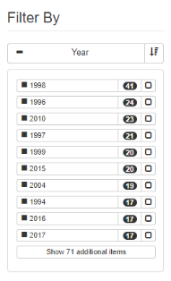
Figure 5 –The Filter By section, containing filter types such as Year.
- Simply click on the button to the right of a particular filter option to enable it, as seen in Figure 6.
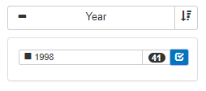
Figure 6 –‘1998’ has been selected as a filter for the search.
- It is also possible to filter on more than one filter type, as seen in Figure 7.
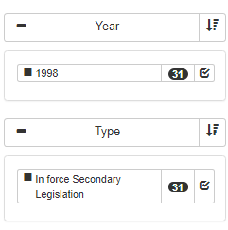
Figure 7 – This combination of selected filter types will only show In Force Secondary Legislation documents from 1998 in the search results.

Browsing
The main menu bar has items that provide access to a browse screen for finding the following types of legislation:
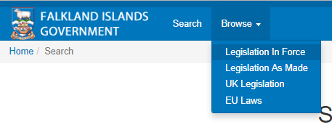
- Legislation In Force
- Legislation As Made
- UK Legislation
- EU Laws
Depending on the type of legislation, there is an option to browse by Title/Year.

By Title
All of the menu bar items for the types of legislation display browse pages configured with a browsing tool for listing legislation as follows:
- Clicking on a letter lists the instruments with a title starting with the selected letter
- Clicking on a year lists the instruments made in that year (Only As Made legislation is viewable by year)
- The < and > arrow buttons at either end of the year list scroll the range of years up or down
- Note: The years may not be contiguous, especially for earlier years, since years are only shown for which there are instruments
For each type of legislation there is a browsing tool each for Ordinances and Secondary legislation.

Browse Results
In response to clicking on a letter/year in the list selection tool, the selection is highlighted and the results are displayed in a Results section positioned below the Browse tools section, as shown in Figure 6. The section is comprised of a results table that occupies most of the section and is accompanied with a row above and a row below the table to accommodate tools for use with the table.
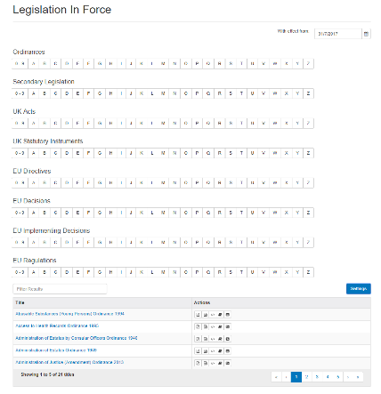
Figure 5 – Browse page with Results section
below the browse tools section
The first row of the Results section provides functionality as follows:
- A settings button that allows for changing the amount of results per page.
- A tool for filtering the browse Results list, using a specified term

The list of legislation that meets the browse criteria is displayed in a table offering the following functionality:
- Selected metadata for each item is displayed in columns as follows:
  - Title (that is a clickable link to the Document View of the instrument)
- The title column heading is clickable to specify ascending/descending sort that is indicated with a darker (enabled) up/down arrowhead located to the right of the heading
- An additional Actions column provides six tools for use with each item in the list:
  - Download PDF () button – downloads the PDF document for the selected title
  - Download Word ()button – downloads the Word document for the selected title
  - Download Legislative History ()button – downloads the XML document for the selected title
  - View Whole Document ()button – that displays a Document View of the entire instrument with hit highlighting
  - New or updated Versions Feed () button – Downloads the new or updated versions feed for the selected title
The last row of the Results section provides functionality as follows:
- The range of items displayed out of the total number of items in the results list
- A navigation tool bar with buttons for navigating around the various pages of items in the browse Results list with functionality as follows:
  - << – when enabled, displays the first page of items
  - < – when enabled, displays the previous page of items
  - Up to five numbered buttons enabled, for non-empty lists,
  - > – when enabled, displays the next list of items
  - >> – when enabled, displays the last page of items

Document View
The Document View, as shown in Figure 7, is comprised of a contents pane, or panel, on the left side that shows the structure of the instrument, and a large content viewing area for the text of the document being viewed. There is also a section (or Instrument/Document Toolbar) with various document related tools positioned at the top of the content viewing area.
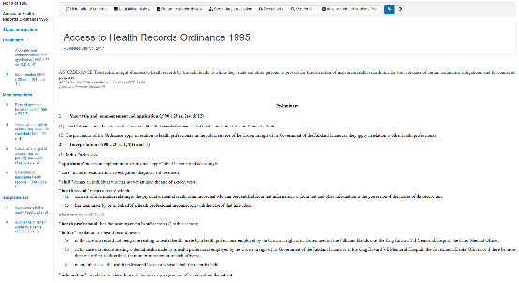
Figure 6 – Document View for an instrument

Contents Pane
The contents pane, positioned on the left of the screen, is populated with links to specific parts of the instrument that constitute its structure, such as: Chapter, Part, Division, and Schedule. Depending on whether the whole document is loaded and displayed in the content viewing area, clicking on an entry in the contents pane results as follows:
Whole document: | the content viewing area will still contain the whole document, however the document will be scrolled up/down to display the content for the part of the document selected in the contents pane
Document part: | only the specific part of the document, including its provisions, are displayed in the content viewing area

Content Viewing Area
The content viewing area, as shown in Figure 8, occupies the largest part of the screen to display content which may be the whole instrument, a single Part, a single provision or multiple provisions. This area is arranged as follows:
- A Document Toolbar positioned across the top
- A row with search information (for search results)
- Hit related tools (for search results)
- The name of the instrument and the time and date it was published
- The text viewing area, with hit highlighting for search results, that may contain links to other sections within the document or links to other legislation documents
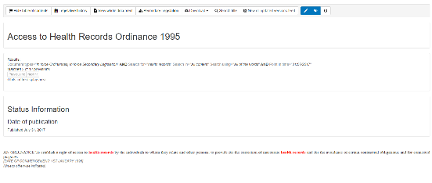
Figure 7 – Content viewing area
with hit highlighting (from a search result)

Document Toolbar
The Document Toolbar, positioned at the top of the content viewing area, provides sets of grouped tools that provide functionality as follows:
- Instrument related viewing options:
Hide table of contents button /Show table of contents button | - hides the contents pane. When the contents pane is already hidden, the button will display the contents pane
Legislative history button | - displays the legislative history for the instrument
View whole document button /Return to standard view button | - displays the whole instrument in the content viewing area. When the whole instrument is being displayed, instead returns to the standard view
Secondary/Enabling legislation button | - loads a search result page listing the secondary/enabling legislation for the instrument
Download button | - allows the user to download the instrument in various formats
Search Title button | - loads the Basic search page with the Search for field set for the current instrument
- Instrument related actions:
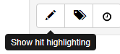 | - toggles the display or hiding of hit highlighting
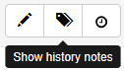 | - toggles the display or hiding of history notes, where present, at the end of the fragment in the content viewing area
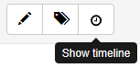 | - toggles the display of the timeline for the instrument

Hit Highlighting
Document views arising from search results have the matched terms (hits) highlighted in the document content viewing area. When document views contain hit highlighting, an additional section is added below the Document toolbar to display search information and hit related tools as follows:
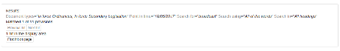
- The first line displays:
  - the query that was applied along with user input parameters
  - the number of fragments/provisions containing a match out of the total number of instrument provisions
- Using the example above, the second line provides hit information and tools for navigating the hits in the content viewing area as follows:
- only available when not viewing the whole document in content viewing area
- displays the previous/next fragment containing hits
- button only enabled when there is a previous/next fragment with hits (in this example, the Previous button is disabled since it is the first fragment containing hits)
- information about the number of hits in the content displayed in the content viewing area
- scrolls the content viewing area display, if required, to display the first/last hit in the content
While search terms matched in the document content are highlighted, terms that are matched in metadata, which is not displayed, are not highlighted anywhere. Consequently, it is possible to have documents retrieved as the result of a search for which there are no hits in the document content.
Hit highlighting colours the matching term(s) in the content viewing area in a bold red coloured font. Apart from the first and last hits displayed in a document, the matches have a clickable link as a prefix and a suffix (when hovering) for jumping to the previous and the next hit respectively.

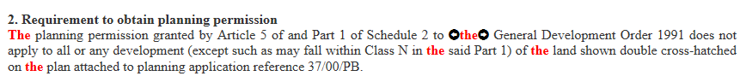

Legislative History
The Legislative History page provides information about revisions to the instrument as well as a list of legislation containing commencement information. The Legislative History page is accessed by clicking the title of a record returned from any search or browse result as seen in Figure 9.
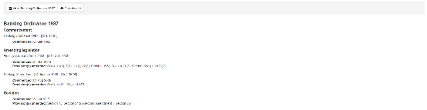
Figure 8 – Legislative History page

Profile
The Profile page is used to manage a user’s details, password settings and to allow the user to download collections of data from the database, either as a whole or only sets of data that have been added since the last download of a collection. The Profile page is accessed by clicking the Profile navigation link. Upon clicking the link, the user will be displayed information relating to themselves/the owner of the account, a Change password button and the Subscriptions tab.
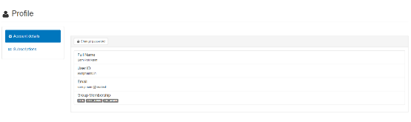
Figure 9 – Profile page
Access to the Profile page is only available to authorised users who have an SLS (Security and Logging Server) account. Upon navigating to the above URL, or clicking the Login button, the user is presented with a login dialog:
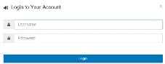

Change password
To change an account password, go to the Profile page and click on the Change password button depicted below:

Clicking the button opens a modal window that allows users to change their password. To successfully change a password, the user’s current password must be entered in the Current password field, and the new password to be entered twice into both the New password and Confirm new password fields.
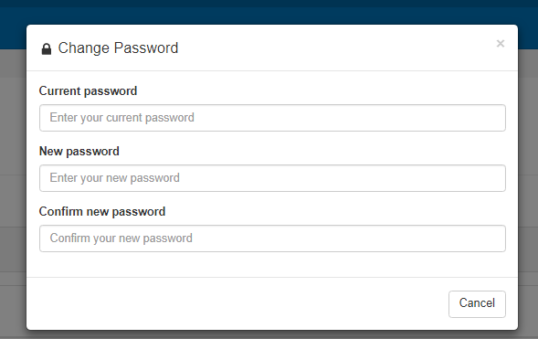
New passwords must meet the required password length of 8 characters, and ensure that both the values in the New password and Confirm new password fields are the same. 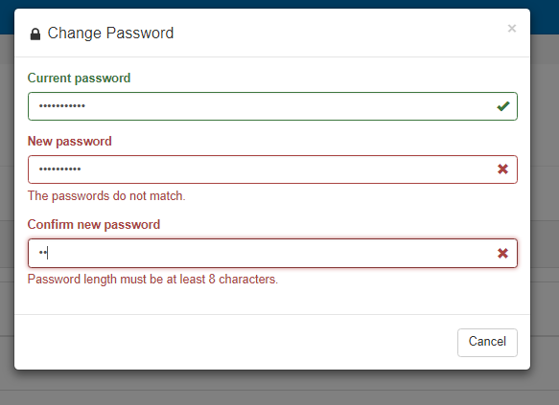

Subscriptions
Upon first visiting the Subscriptions page, a user will only have one button to click:
Upon clicking this button the user will be given options to download the entire collection of data in any combination of three formats:
- PDF
- HTML
- Word
A user proceeds to download the selected combination by clicking the Download Selected Renditions button.
Once a user has downloaded the entire collection they will now be displayed with a new option to download updates that have been made to the collection since their last full download in the same format previously requested.
A table will also be visible displaying to the user new legislation since their last full download.
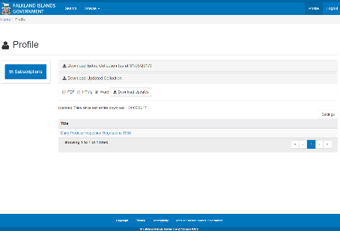
If a user wants to download updates in a format different to previously selected, they must re-download the entire collection in the desired format.

Trademarks
TeraText® is a registered trademark of Leidos Inc (formerly Science Applications International Corporation (SAIC)).

Copyright
This document is copyright by Leidos Pty Ltd, 2017.

Contact details
Tim Arnold-Moore
Leidos Pty Ltd
Level 5, 385 Bourke Street,
Melbourne VIC 3000
AUSTRALIA

Phone: +61 3 8689 0973
Fax: +61 3 8689 0901
Email: timothy.j.arnold-moore@leidos.com

Web: www.leidos.com, www.teratext.com

